**Module 7 Lab 2: HTTP Status/Error**

Saurabh Kale

IFT 458/554: Middleware Programming & Database Security

Dinesh Sthapit

November 19th, 2023

1. **Setting up project-**

App.js-

1. **HTTP Status Codes**

Status code 200-

Status code 201-

Status code 400-

Status code 404-

Status Code 500-

1. **Error Handling and Exceptions**

Log Every incoming request-

Created a middleware function that handles 404 error-

Handle the remaining errors-

1. **Promise Try/Catch**

Output-

**CRUD project:**

**Code-**

**POSTMAN TESTS-**

POST Method-

If title or author is missing-

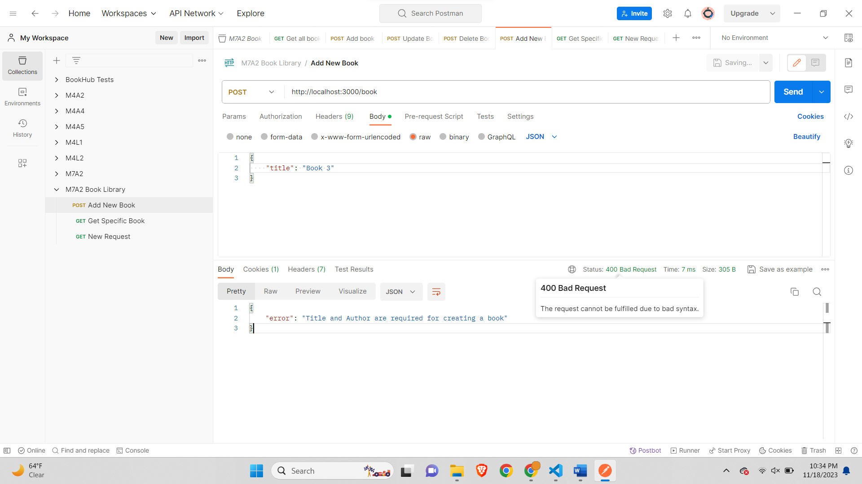

GET Specific Book-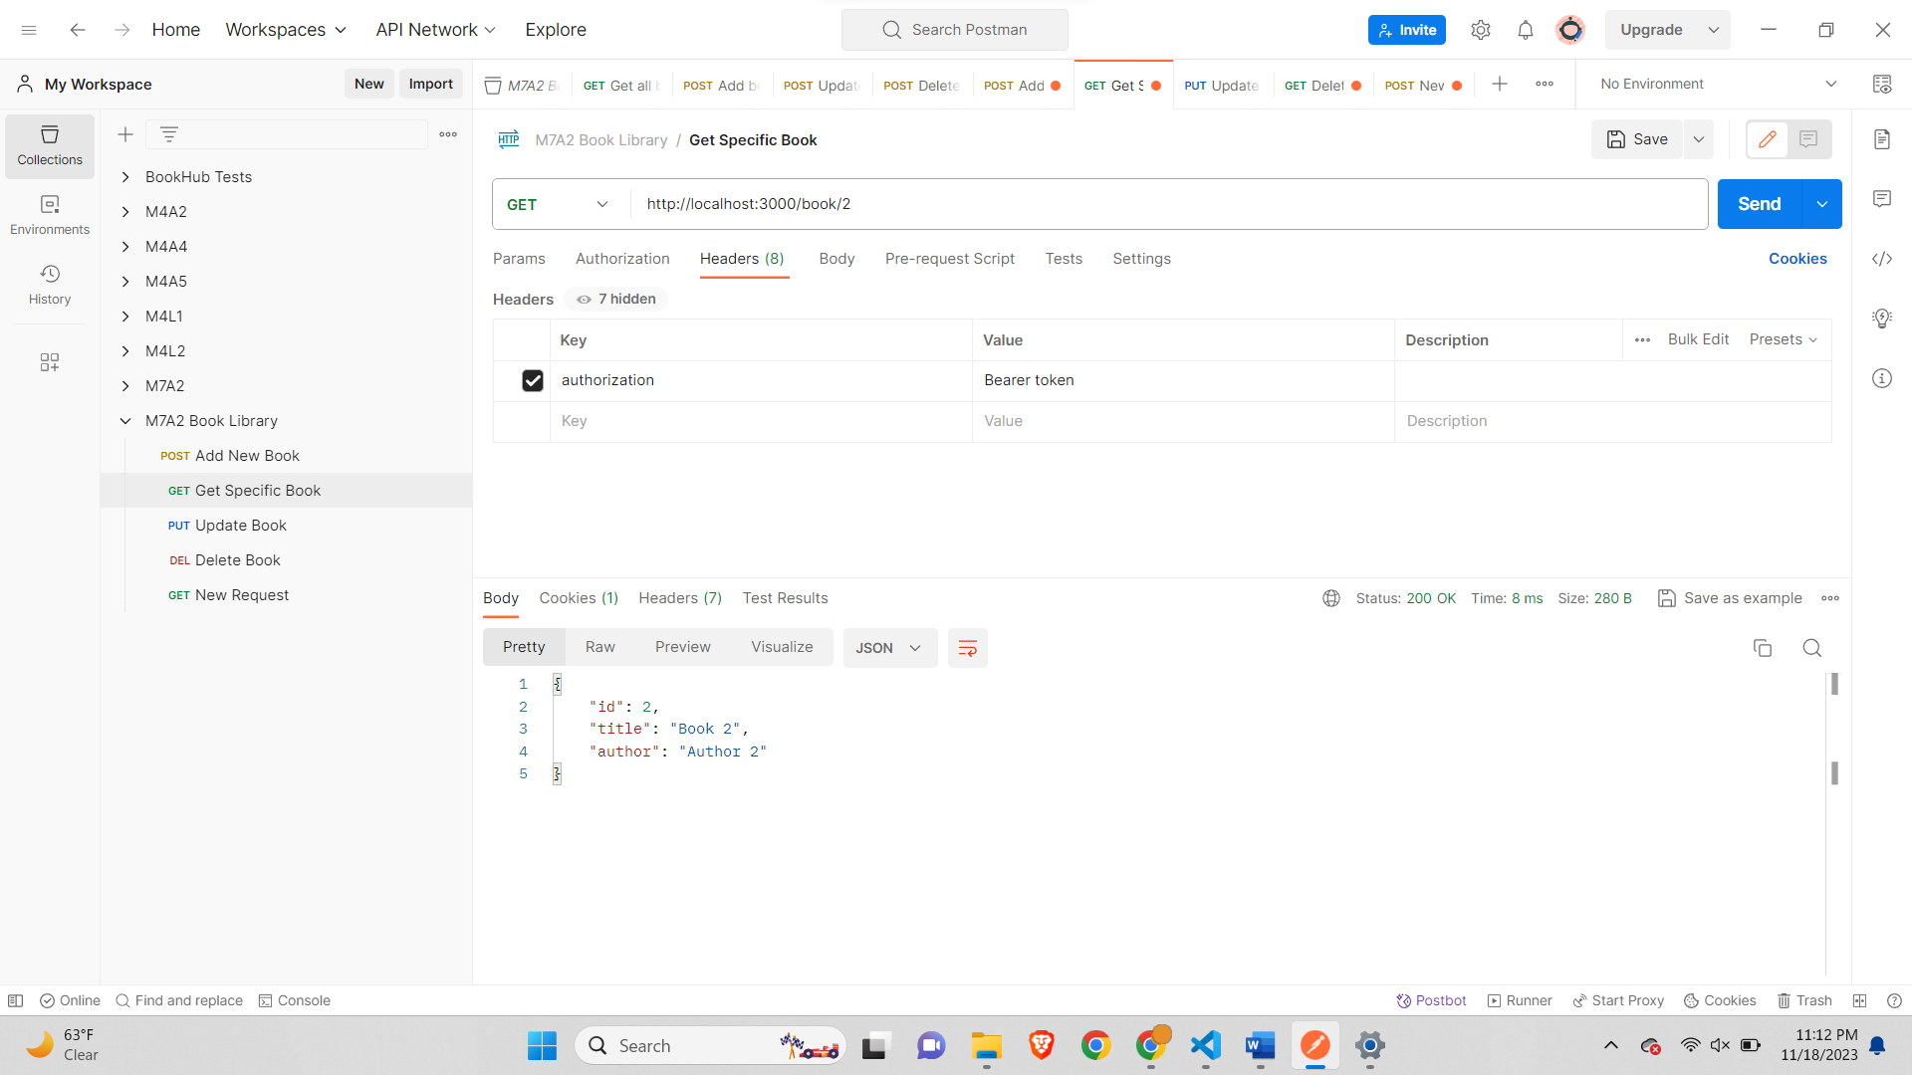

If book is not found-

PUT Book-

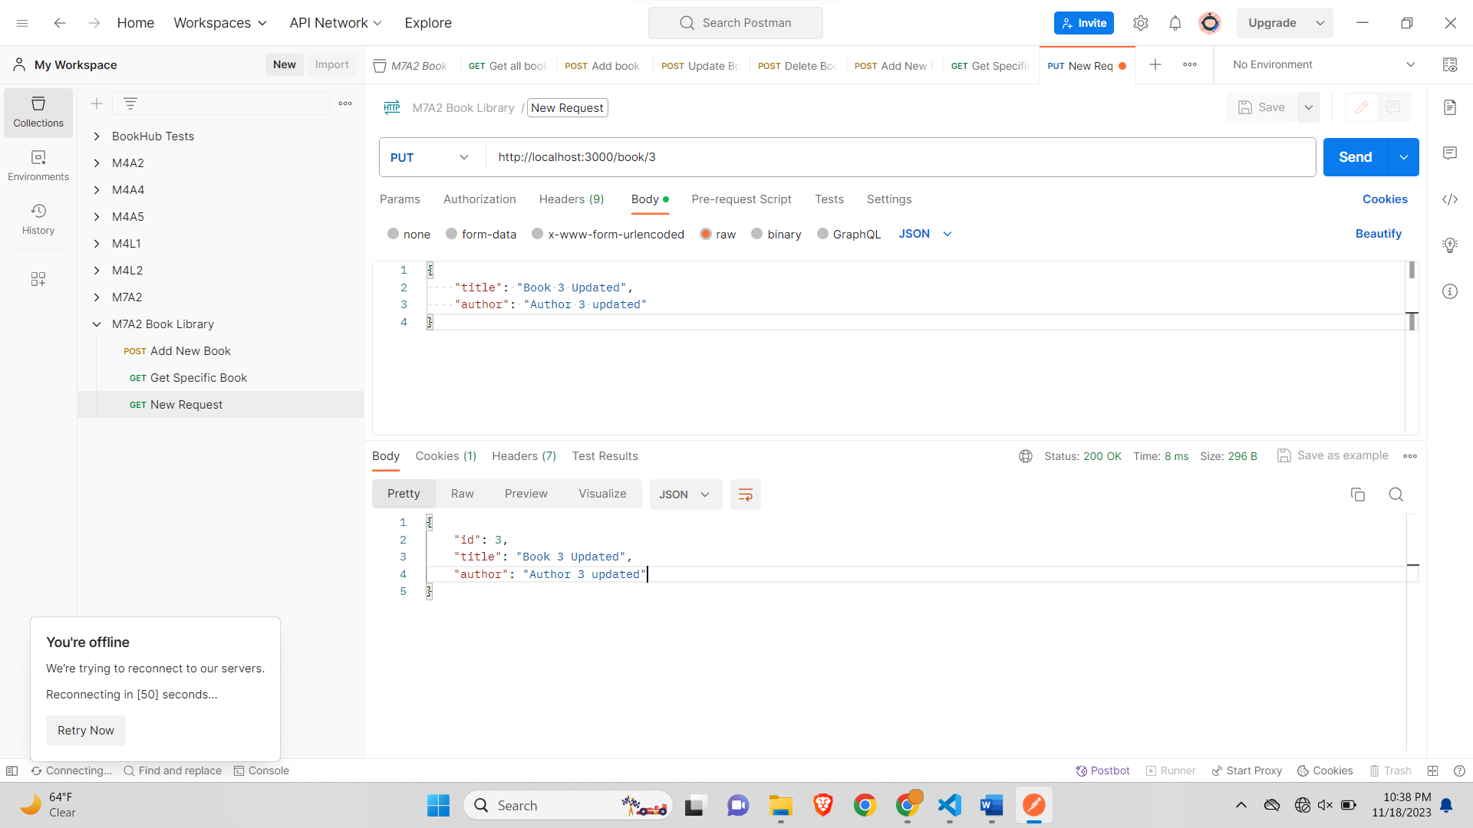

If title or author is missing-

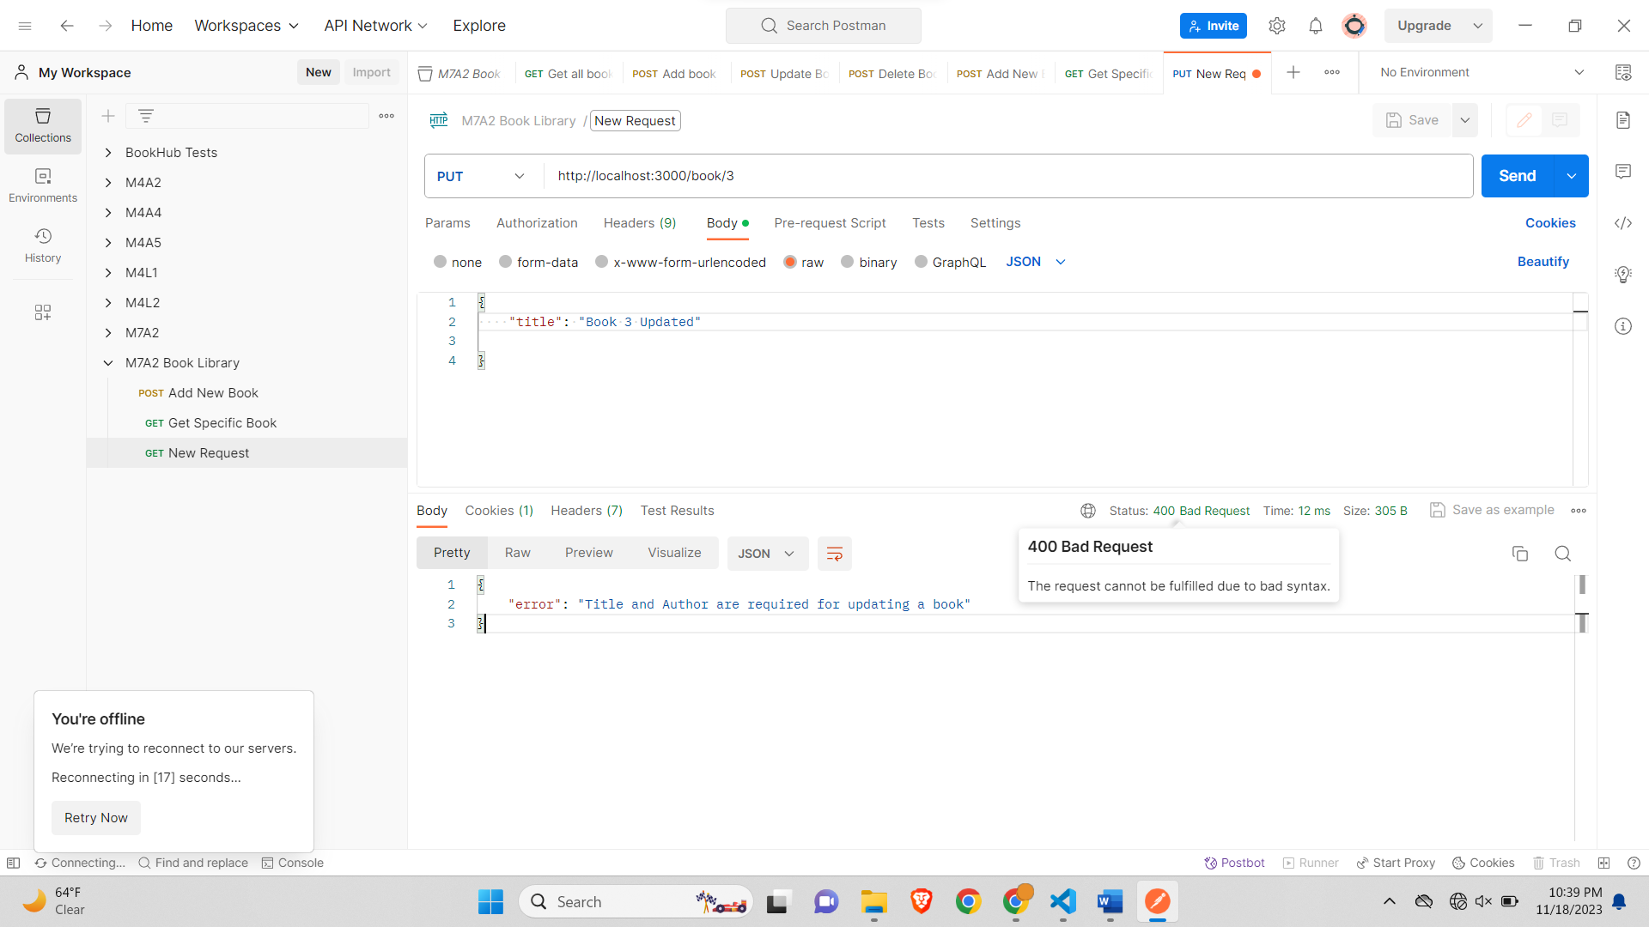

If Book Not found-

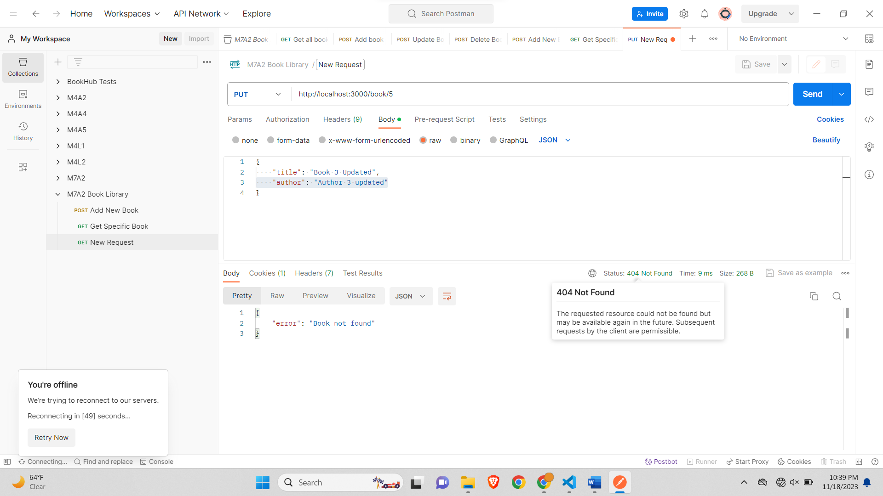

Delete Book-

If Book not found for deletion-

If other route-

Other Errors-

Login-

Invalid Password-

Sign up-

